PROBLEM STATEMENT

# OVERVIEW

The asset management software uses the data from a single table in a database from SQL Server. The trial on making the data table dynamic by giving new column feature was carried out.

The project uses the Entity framework method for the data binding. So it includes the database by an ADO.NET data entity model. When the query for adding new column is called with the defined table name, column name and its type the sql query affects the original table in the SQL Server, but the model imported tends to be the same in the .NET project. So we need to derive a solution for dynamic update of data model during runtime.

## Adding Column in Front end

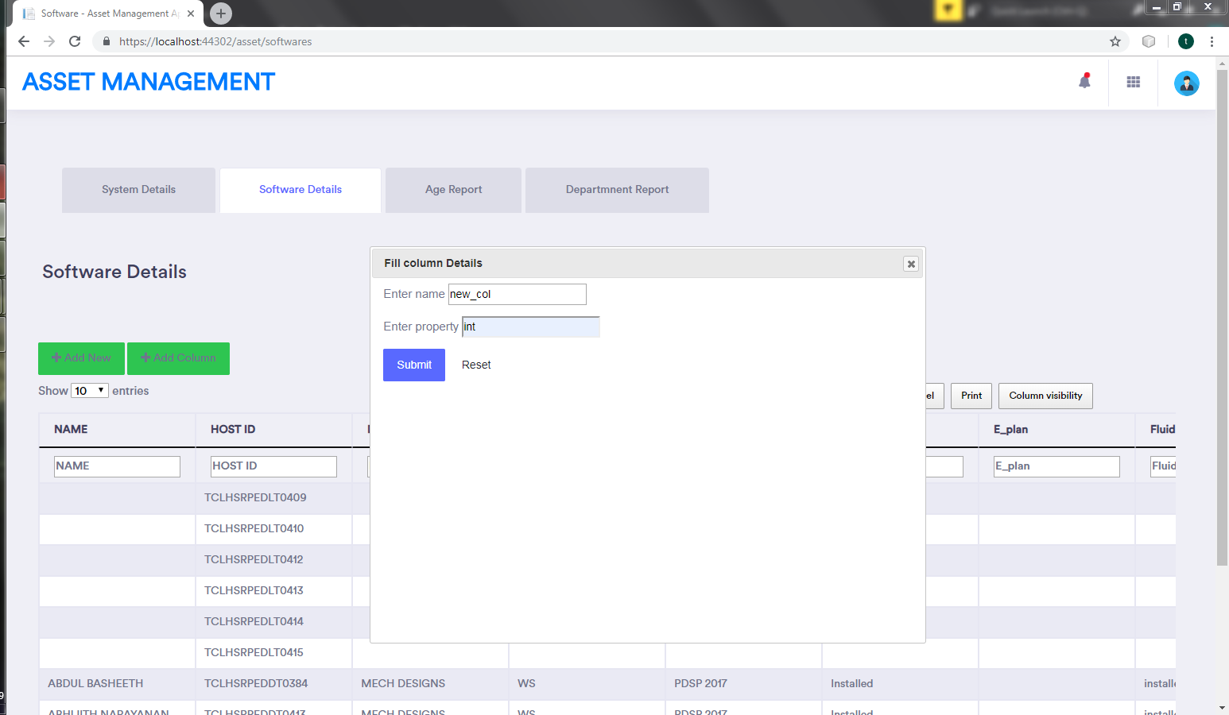

## Querying from controller to create column:

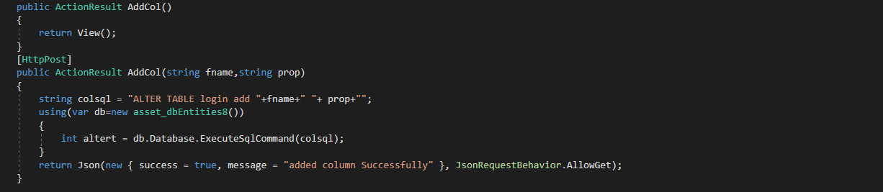

## Query getting reflected in the Database

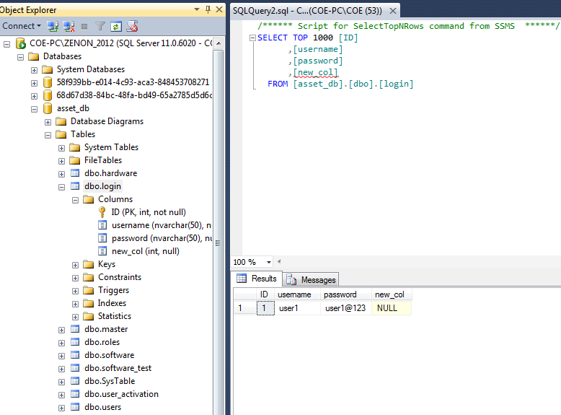

## Need to derive a solution to update model at runtime:

